**Logistic Regression Overview**

Logistic regression makes use of the sigmoid function which outputs a probability between 0 and 1. The sigmoid function with some weight parameter θ*θ* and some input x(i)*x*(*i*) is defined as follows.

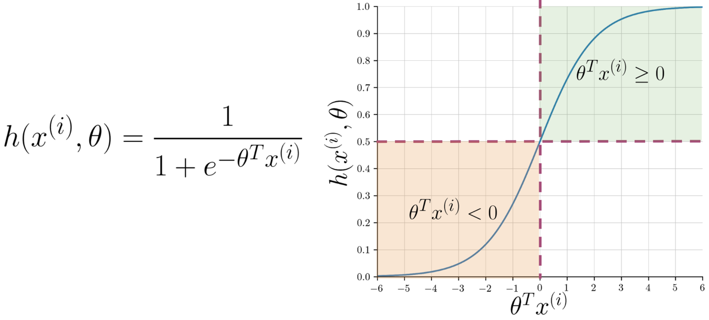

Note that as θTx(i)*θTx*(*i*) gets closer and closer to −∞−∞ the denominator of the sigmoid function gets larger and larger and as a result, the sigmoid gets closer to 00. On the other hand, as θTx(i)*θTx*(*i*) gets closer and closer to ∞∞ the denominator of the sigmoid function gets closer to 1 and as a result the sigmoid also gets closer to 11.

Now given a tweet, you can transform it into a vector and run it through your sigmoid function to get a prediction as follows:

